**Game Rules**

4-6 players

In the game of ‘Judgement’, the humans form a voting committee in order to compete for a future life in another realm. These humans have been entrusted to question what is true, to refine who is worthy of the afterlife. Humans who must tell a lie have been temporarily tainted with sin, for the purposes of testing other humans. Players will score points depending on their ability to correctly judge other player’s experiences. With a clearer perception of their fellow human beings, they become closer to a higher consciousness, worthy of the afterlife.

**Set-up:**

You will need:

* 2 liar counters (red) and enough truth counters (green) to make up the number of players (e.g. 6 players will need 2 liar tokens and 4 truth tokens) placed into the counter bag
* 2 voting tokens each
* A character card placed in front of each player

Place the betting board and the question cards in the middle, separated into categories

**Example Set-up for 6 player game:**



Question Cards

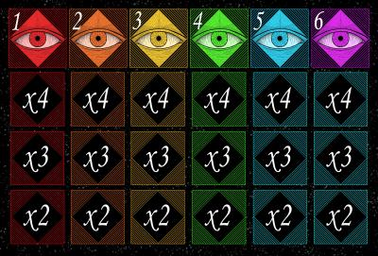

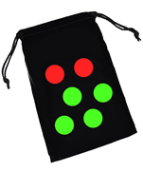



Voting Tokens

Counter bag containing Truth/Liar counters

Betting Board



Player Character Cards

**Gameplay:**

* Ensure all the truth and liar counters have been placed into the counter bag
* At the start of each round, each player takes it in turns to take a liar/truth counter out of the bag (keep this hidden from the other players!)
* One player at the start of the round must choose a question by taking a card from the top of any category pile and place it in the centre for all players to see. Players take turns to choose a card each round in a clockwise direction, youngest player chooses for the first round.
* Players must all answer the question on the card in the centre. If you have a liar counter (red) you must lie that round, if you have a truth counter (green) you must give a truthful answer to the question.
* After all answers have been given, players can discuss answers and question other players

**Voting:**

* You are trying to discover the liars, make your judgement count!
* Players must vote for who they think is lying by placing their tokens on the betting board in the centre (players can vote at any time during the round, they do not have to wait until all answers have been given)
* Players will use two tokens to vote each round and may place both tokens on the same player or spread their tokens to bet on 2 separate players
* To vote, place your tokens under the number corresponding to the number in front of the player(s) you want to vote for. Once placed, you cannot move or add tokens.
* If you are the first person to bet on a player, place your tokens in the first slot under their number, if you are the second person to bet on a player, place your tokens in the ‘x3’ slot below their number and if you are third or later, place your tokens in the ‘x2’ box.

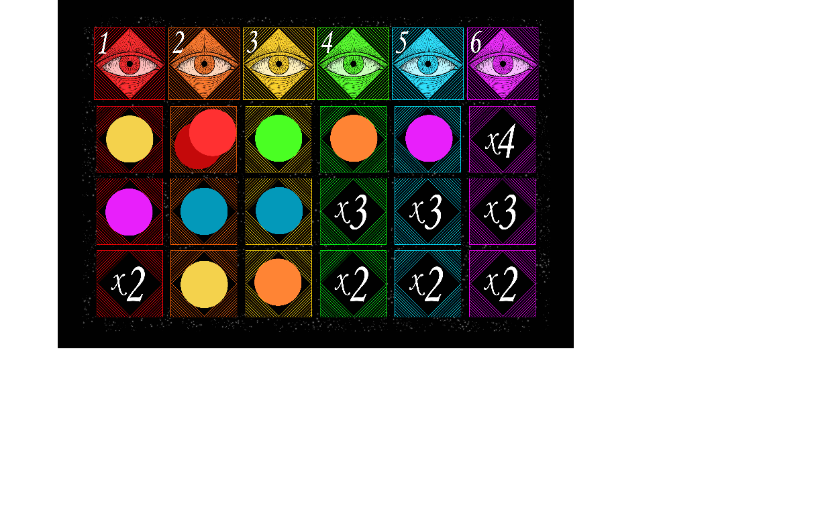**Example:**

1) Player 1 is the first to vote and places both tokens in the ‘x4’ box in player 2’s column on the betting board as they are the first to vote on this player

2) Player 4 is the second to place their vote and places one token in the ‘x4’ box underneath player 3 as they are also the first to vote on this player

3) Player 5 then places their tokens on players 2 and 3, placing them in the ‘x3’ box in each player’s column, as they were the second person to vote on either of those players

4) Player 3 places one token on player 1 in the ‘x4’ slot as they were the first to bet on this player and places their other token on player 2 in the ‘x2’ slot, as they were the third person to vote on this player

5) Player 2 places their tokens on player 3 in the ‘x2’ slot as they were the third person to vote for this player and on player 4 in the ‘x4’ slot as they were the first to vote for this player

6) Player 6 places their tokens on player 1 in the ‘x3’ slot as they were the second player to place tokens on player 1 and on player 5 in the ‘x4’ slot as they were the first to vote for player 5

**Scoring:**

* The box you place your tokens in corresponds to the amount of tokens you will gain for guessing correctly:
* If your tokens are in the x4 box, you will gain 4 times the amount of tokens you placed on a player and gain the token(s) you placed on that player back, if your tokens are in the x3 box, you will receive 3 times the amount of tokens you placed and the token(s) you placed and if your tokens are in the x2 box, you will gain 2 times the amount you placed and the token(s) placed
* If you were a liar that round, you gain one token for each player who didn’t vote for you as the liar
* If you place tokens on a player who was telling the truth, you will lose all tokens placed on this player (liars who voted on truthful people in a round will have their tokens returned!)
* You will always keep 2 tokens, you can never run out of tokens

**Example:**

***\*In this scenario, players 1 and 2 were the liars.***

* Player 1 receives back their 2 tokens placed on player 2 as this was a correct guess, plus 8 tokens for having two tokens in the ‘x4’ slot. Player 1 also receives 3 tokens for being the liar because 3 of the players did not vote for them as the liar.
* Player 2 does not gain any tokens for guessing correctly, as they placed both their tokens on players who were giving truthful answers. However, they receive their 2 tokens back that they used to vote as they are a liar themselves. They also gain 2 extra tokens because 2 out of the 5 other players did not vote for them as the liar.
* Player 3 receives back both of the tokens they used to vote as they guessed both liars correctly. They also gain 4 tokens for having 1 token in the ‘x4’ box under Player 1, and 2 tokens for having 1 counter in the ‘x2’ box on player 2.
* Player 4 loses the token they placed on player 3, as this player was telling the truth
* Player 5 loses the token they placed on player 3, as this player was telling the truth. However, they gain back the token placed on player 2 as this was a correct guess, and 3 extra tokens for having 1 token in the ‘x3’ slot.
* Player 6 loses the token placed on player 5 as they were telling the truth, but gains back the token placed on player 1 plus 3 tokens for having their token in the ‘x3’ slot

**The game ends when each player has had a turn to choose a question card or when a player has hit the maximum number of tokens and there is no more tokens of their colour to collect. The player with the most tokens at the end of the game wins.**